**Unzip Bonify.zip from Bonify_Automation Folder. Copy the folder in Eclipse Workspace.**

From Eclipse > File > Import > Existing Project into Workspace > Next > Select Root Directory > Browse (The unzip Folder) > Click on Finish.

(Project Added into Eclipse)

**Eclipse Setup for Junit :**

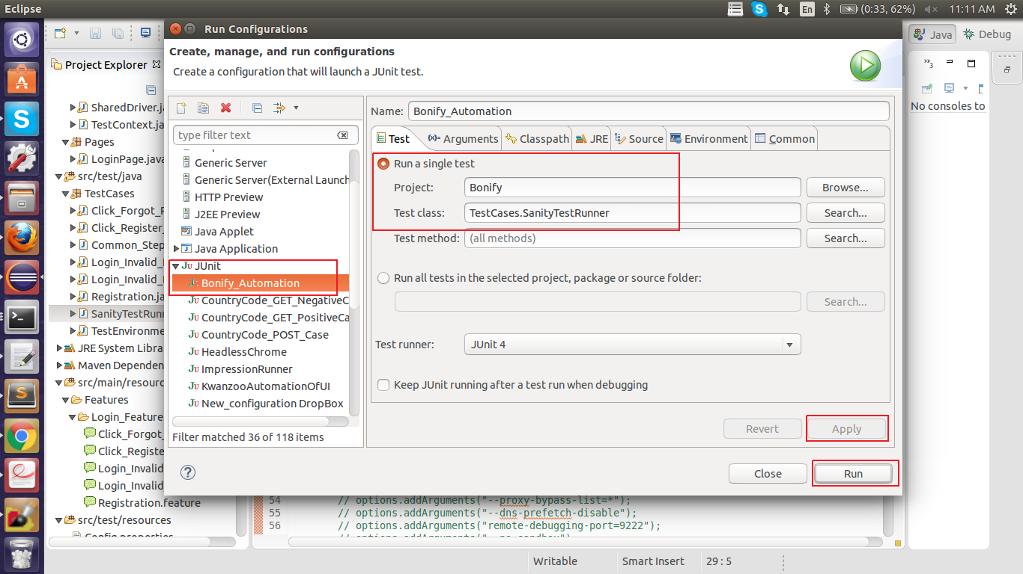

**Eclipse Setup for Maven :**

**1: Open Eclipse and try the code as Junit. Once successfully run verify the result. (Already Done)**

**2: Eclipse -> Run -> Run Configurations -> Select Maven Build -> Add it >**

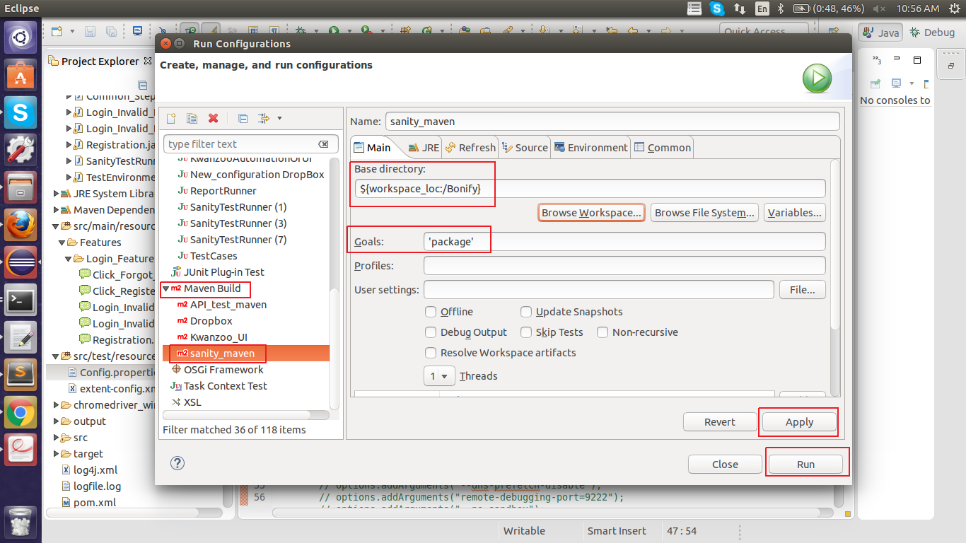

**3: Once Done Click on Apply and Run Button.**

**4: Eclipse will give Console Log as : (Please verify no error in below logs)**

[INFO] Scanning for projects...

……….

[INFO] ------------------------------------------------------------------------

[INFO] **BUILD SUCCESS**

[INFO] ------------------------------------------------------------------------

[INFO] Total time: 4.442 s

[INFO] Finished at: 2018-10-23T11:02:52+05:30

[INFO] Final Memory: 14M/214M

[INFO] ------------------------------------------------------------------------

**5: This indicates build is successful.**

**6: Go to Command Prompt (Terminal), with the project location.**

Eg: cd /eclipse1/workspace/DropBox

And run :

**arun@gs-2514:~/eclipse1/workspace/Bonify$ mvn -Dtest=TestCases.SanityTestRunner test**

It will execute the automation script from starting browser and executing test.

**Terminal Log :**

**arun@gs-2514:~/eclipse1/workspace/DropBox$ mvn -Dtest=TestCases.SanityTestRunner test**

[INFO] Scanning for projects...

[INFO]

…….

1 Scenarios (1 passed)

3 Steps (3 passed)

0m28.018s

Tests run: 4, Failures: 0, Errors: 0, Skipped: 0, Time elapsed: 29.305 sec

Results :

Tests run: 4, Failures: 0, Errors: 0, Skipped: 0

[INFO] ------------------------------------------------------------------------

[INFO] **BUILD SUCCESS**

[INFO] ------------------------------------------------------------------------

[INFO] Total time: 31.469s

[INFO] Finished at: Tue Oct 23 11:12:06 IST 2018

[INFO] Final Memory: 10M/211M

**Jenkins Setup for Running Automation Script :**

**1.a: Job Creation:**

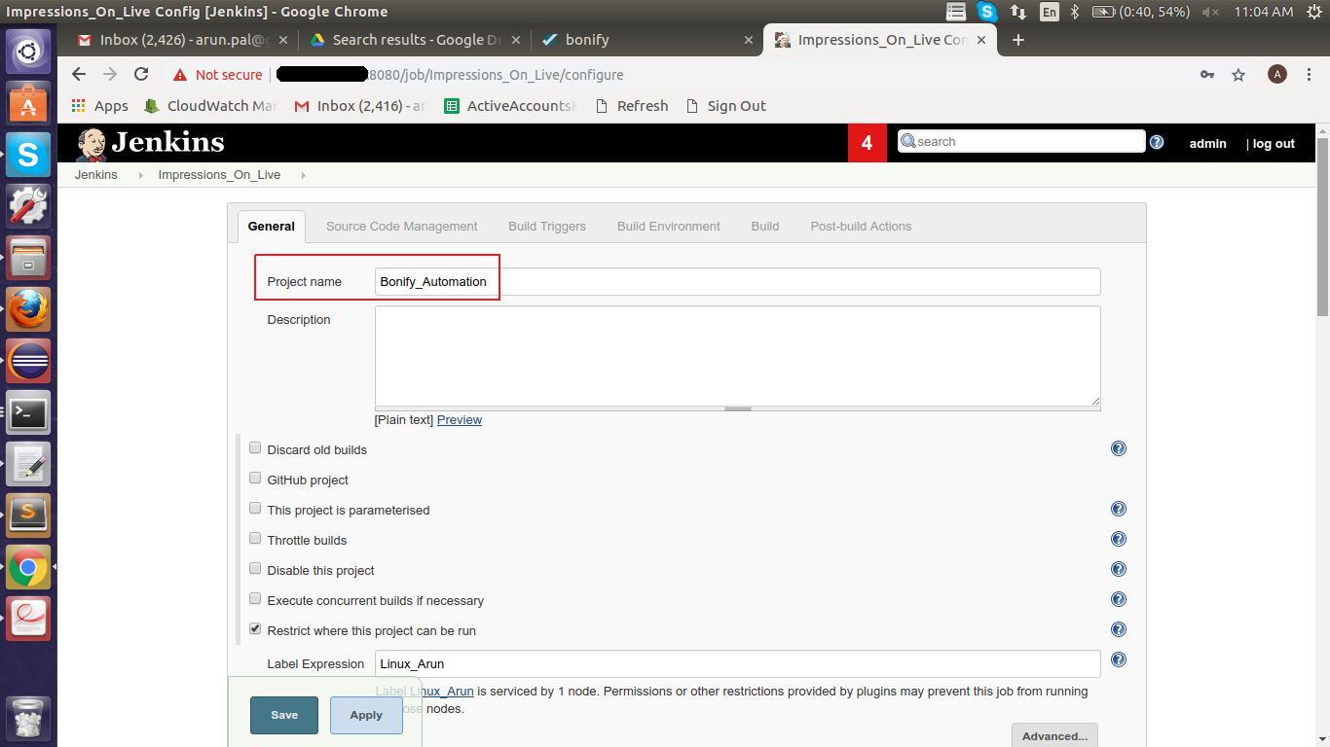

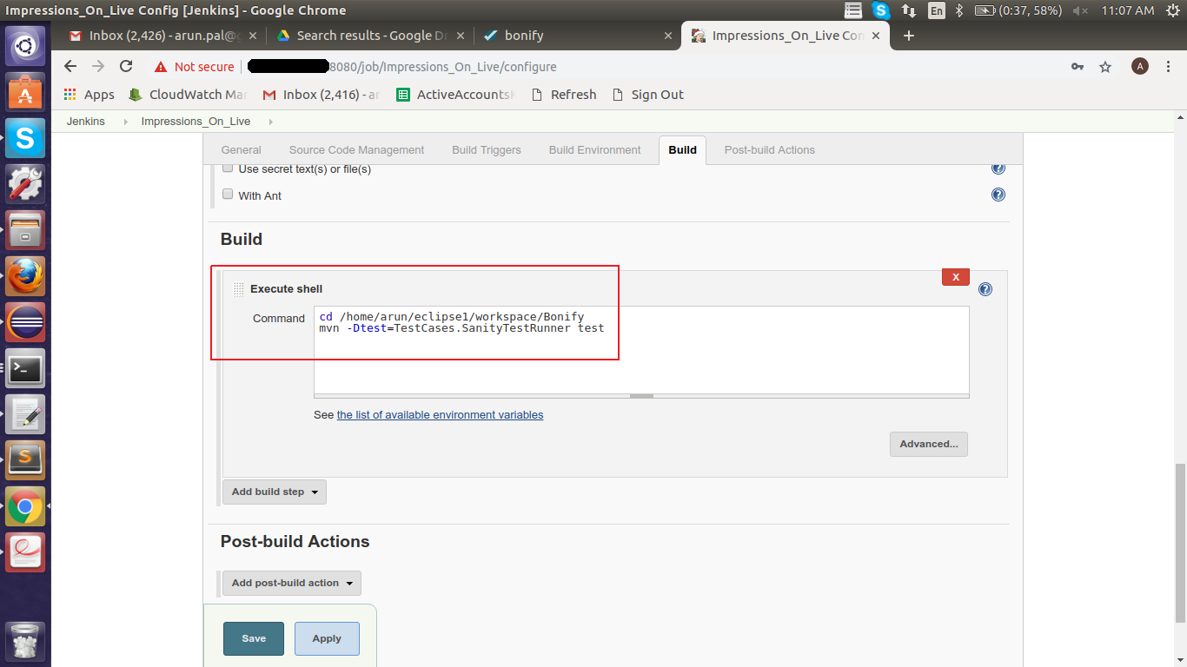

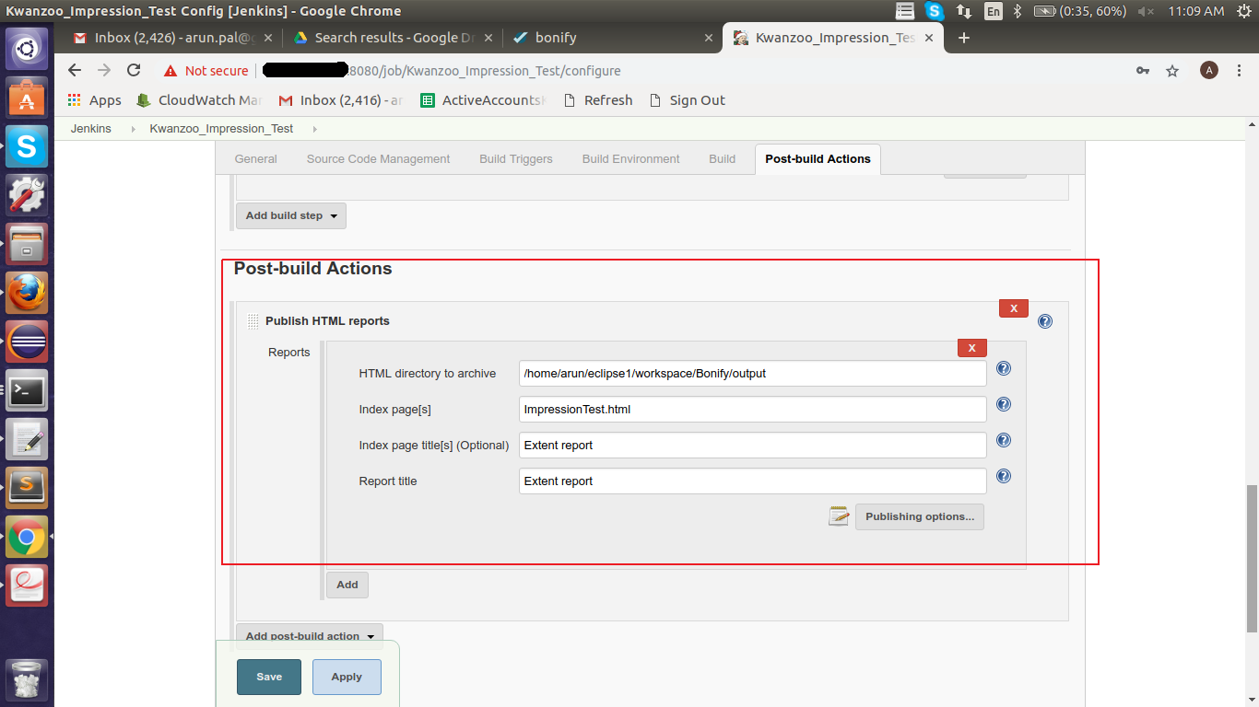

**1.b: Node Creation.**

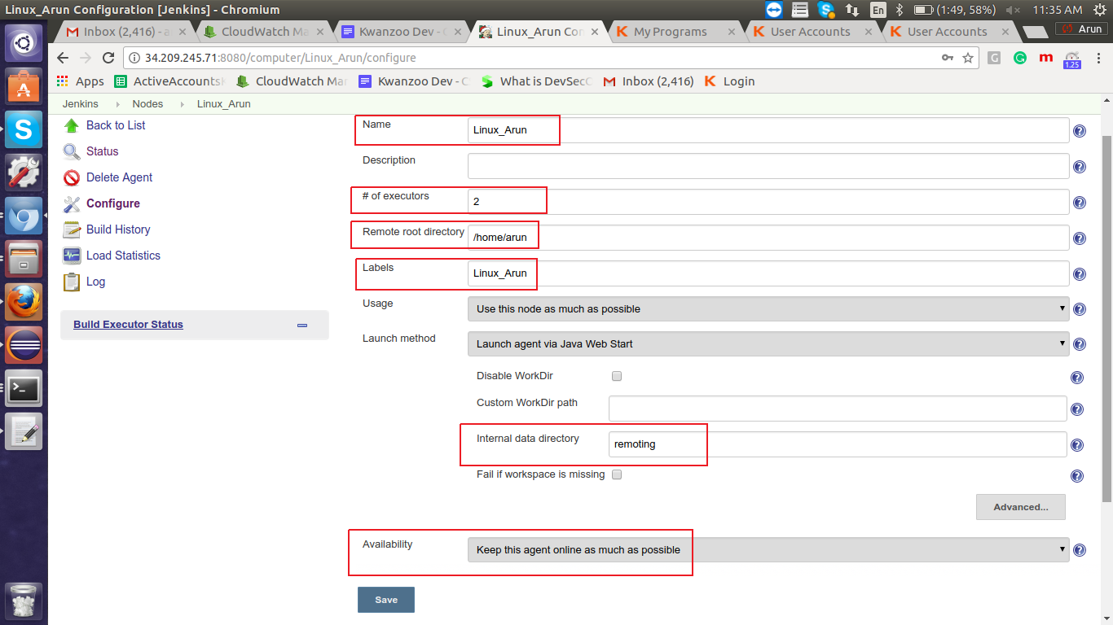

1.c: Node Execution:

> ‘slave-agent.jnlp’ will be install in your machine. Double click on that it will start the node.

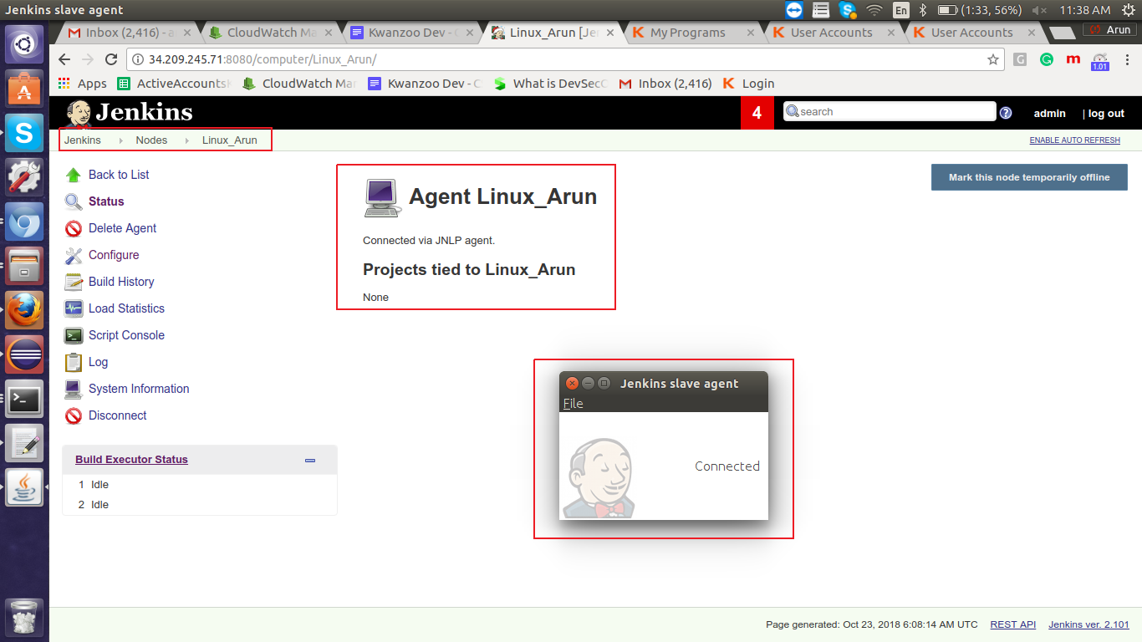

**Extend Report Format:**

